TASK ON VPC -01
- Create VPC with 2 private and 2 public subnets

1. Create VPC
- Go to Amazon VPC Console
- Click Create VPC
- Choose VPC only
- Enter:
  - Name: My-VPC
  - IPv4 CIDR block: 10.0.0.0/16
- Click Create

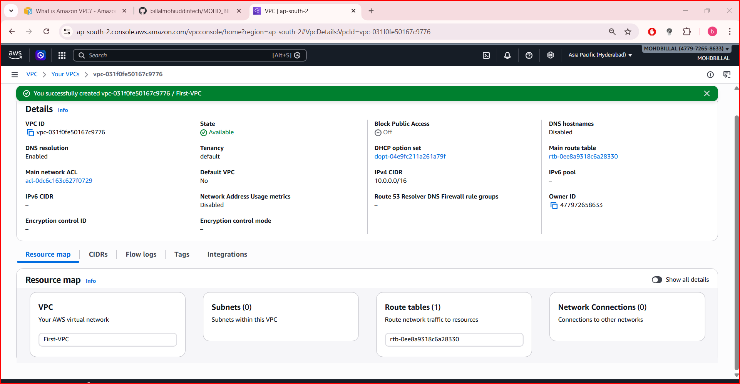
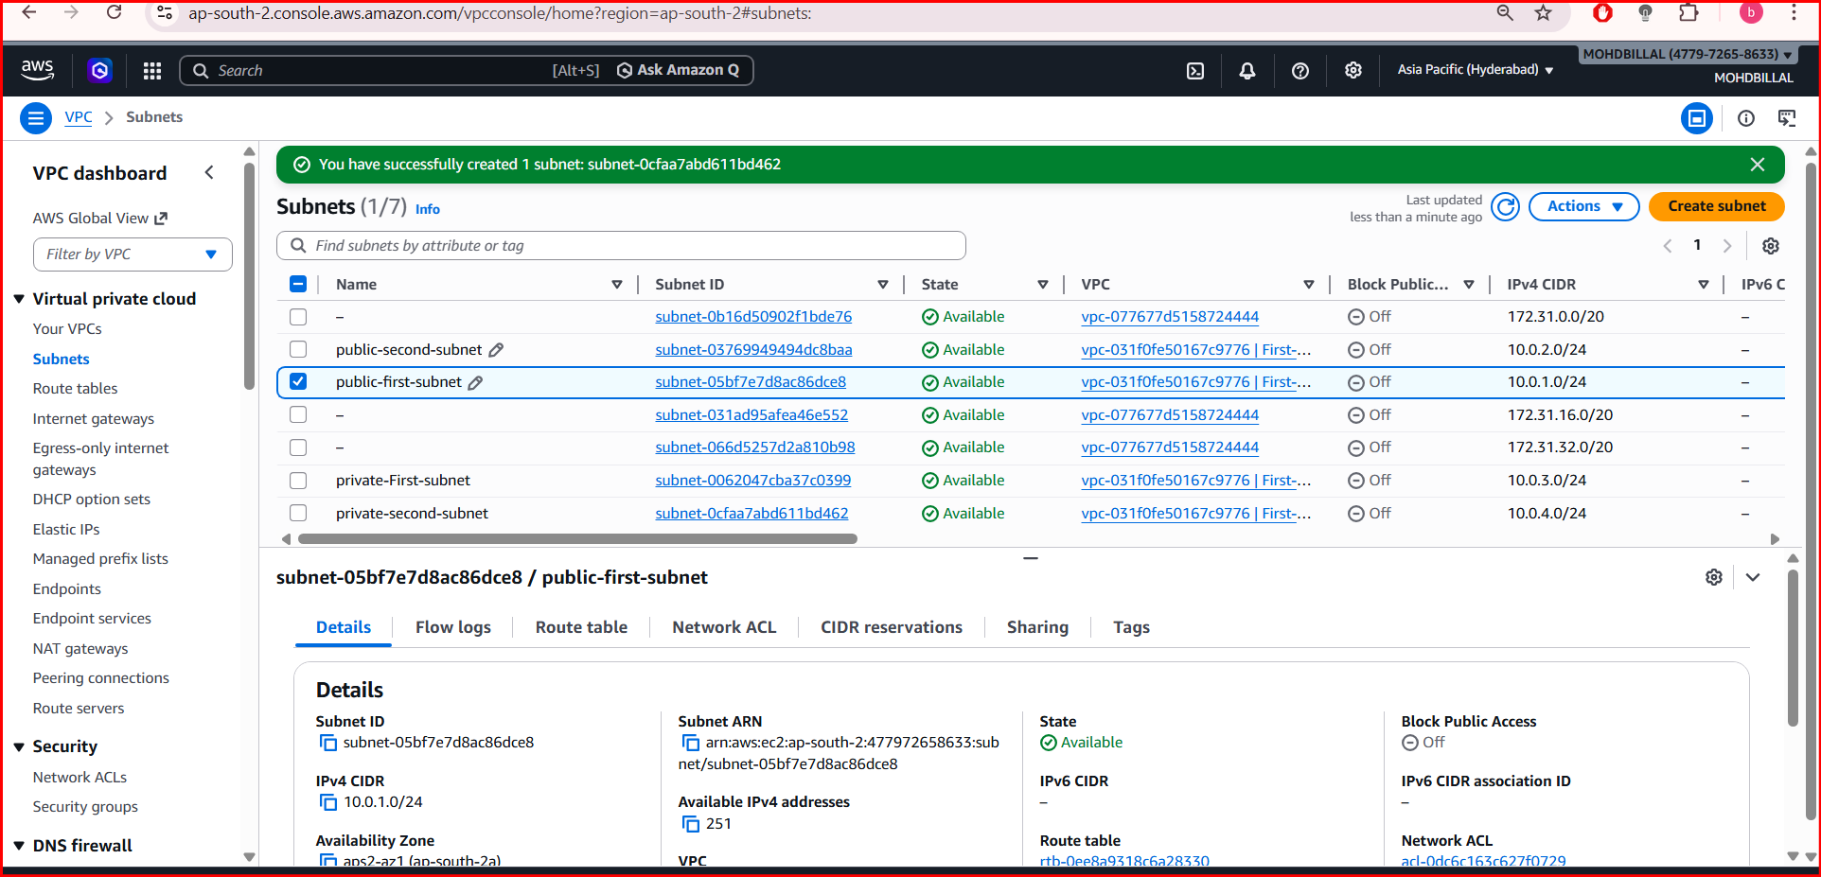
2.Enable DNS Hostname in VPC.
- Select the created VPC
- Click Actions → Edit VPC settings
- Enable:
  - DNS resolution
  - DNS hostnames
- Save.

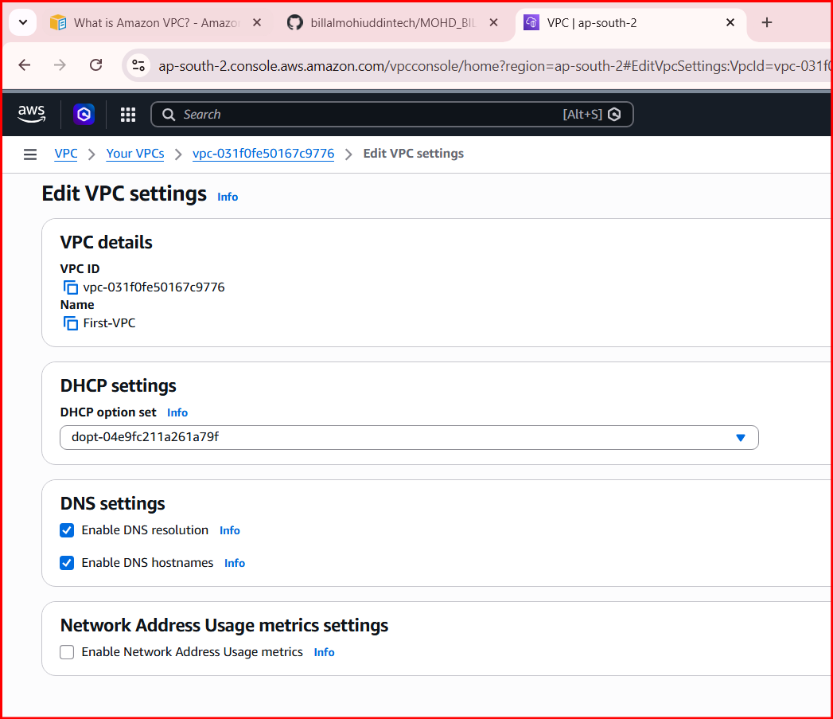
3. Create 4 Subnets
Go to Subnets → Create Subnet

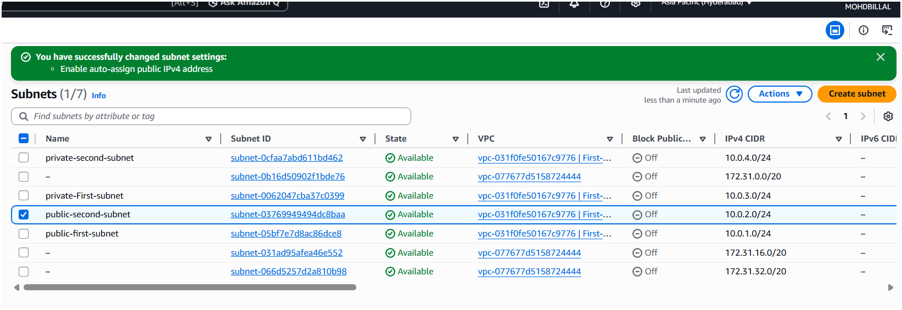

4. Enable Auto Assign Public IP (Public Subnets)
- Go to Subnets
- Select Public-Subnet-1
- Click Actions → Edit subnet settings
- Enable Auto assign public IPv4
- Repeat for Public-Subnet-2
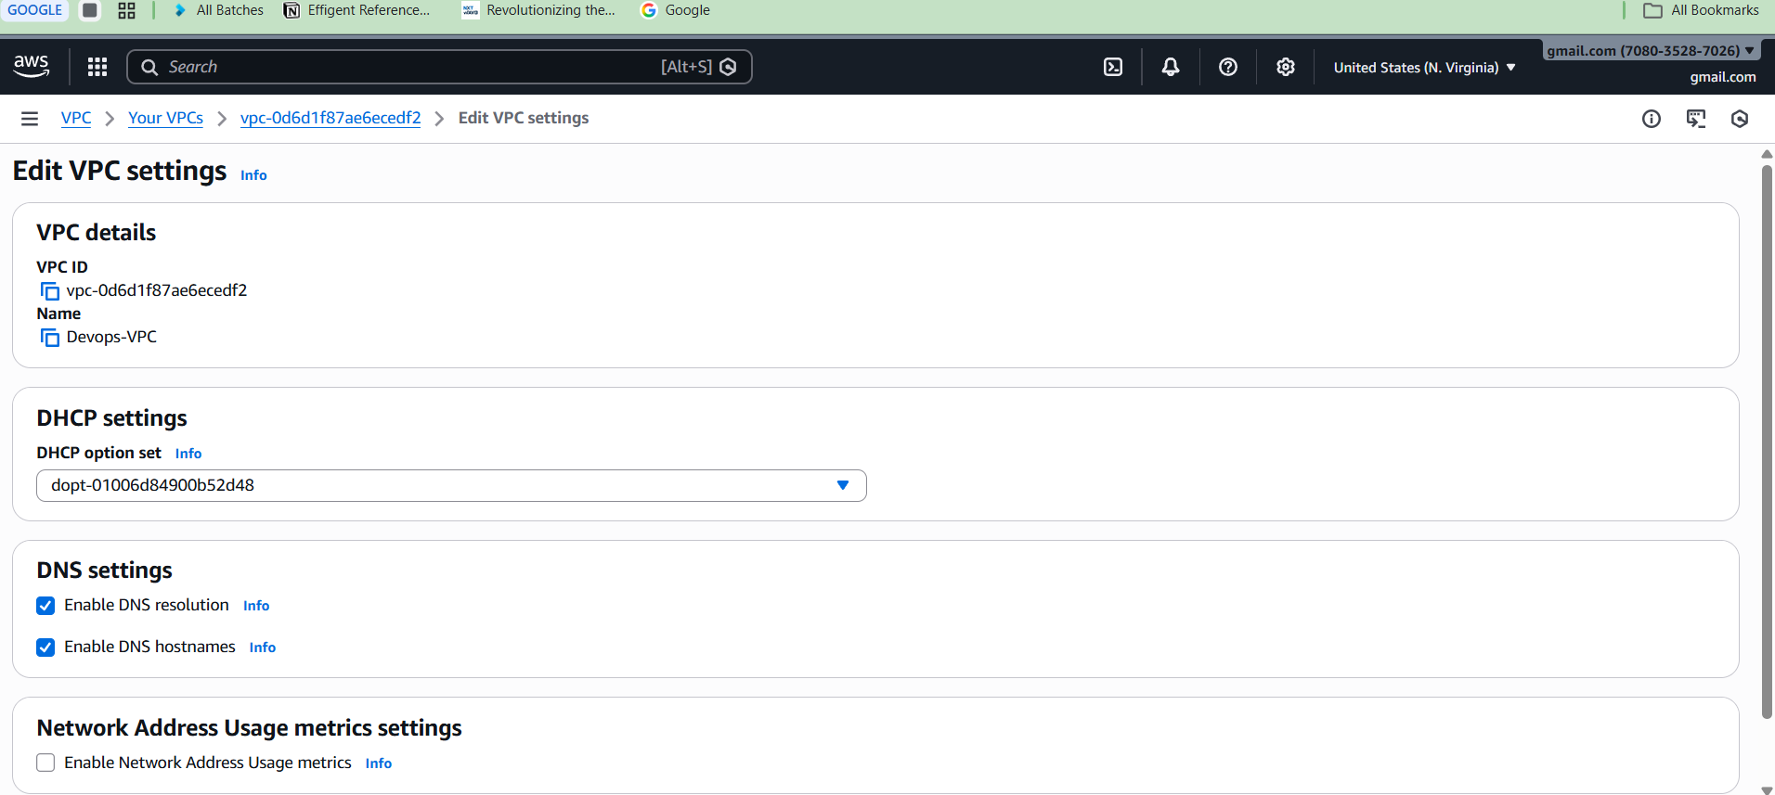
5. Create Internet Gateway
- Go to Internet Gateways
- Click Create Internet Gateway
- Name: My-IGW
- Create
- Click Attach to VPC
- Select your VPC
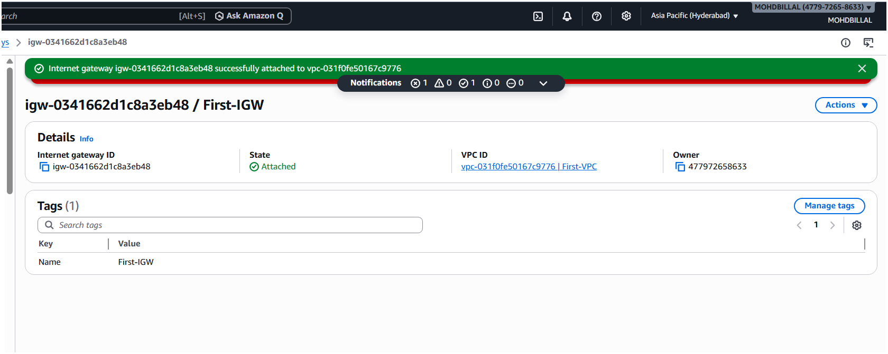
6. Create Route Tables

Public Route Table
- Go to Route Tables
- Create route table
  - Name: Public-RT
  - VPC: My-VPC
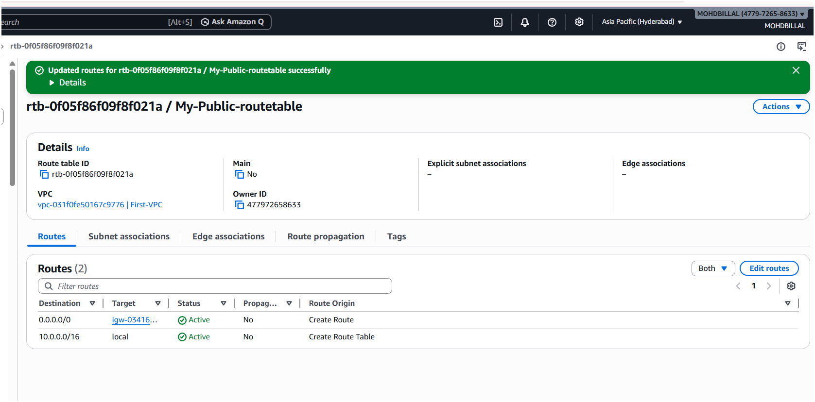
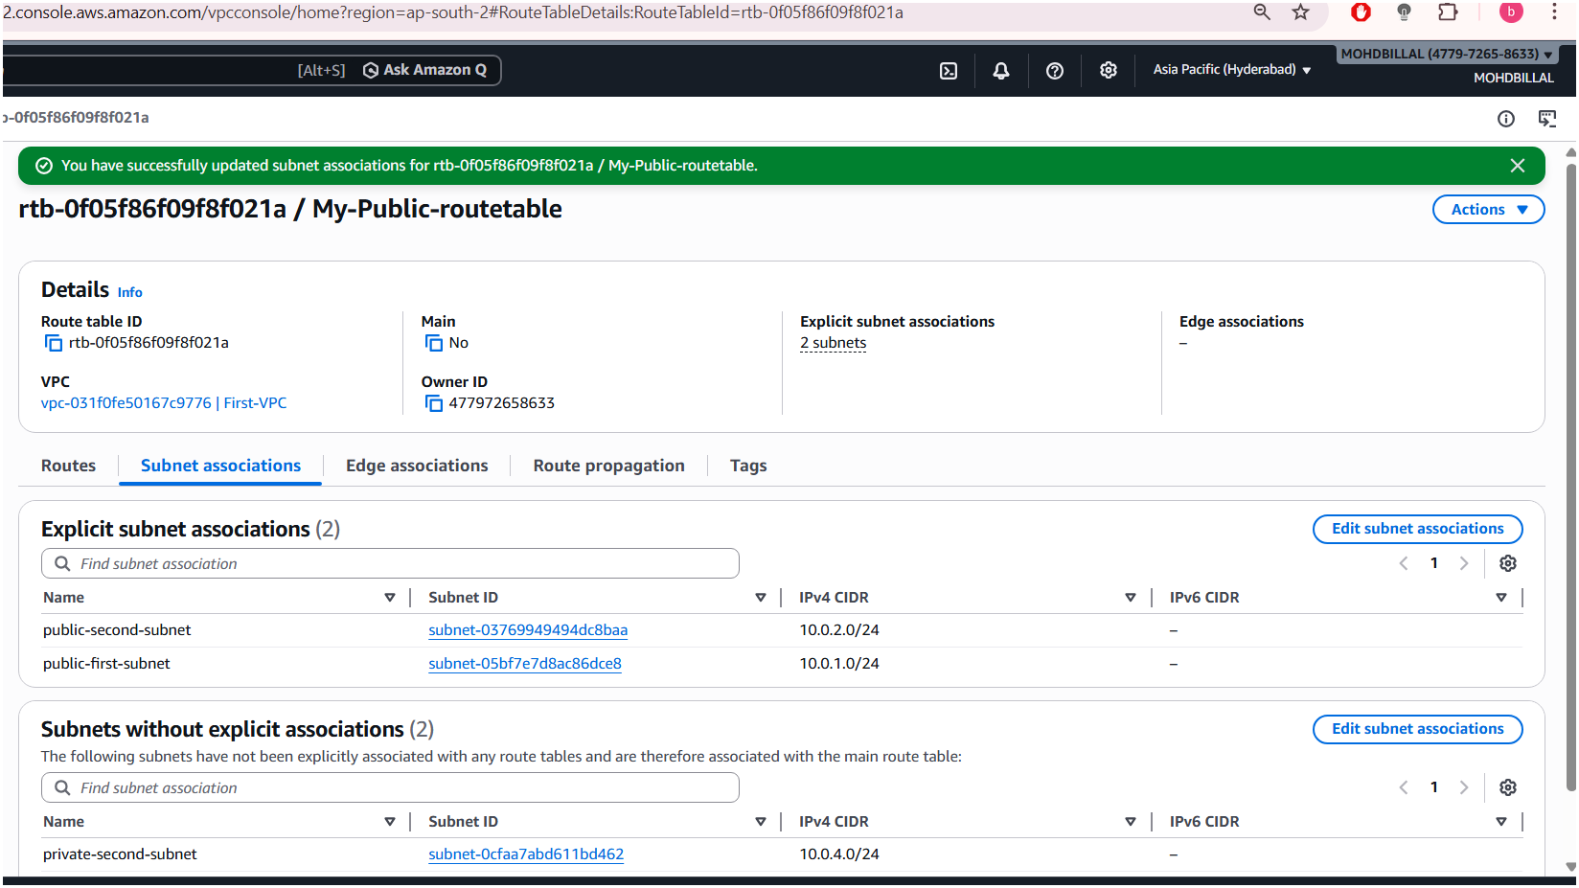
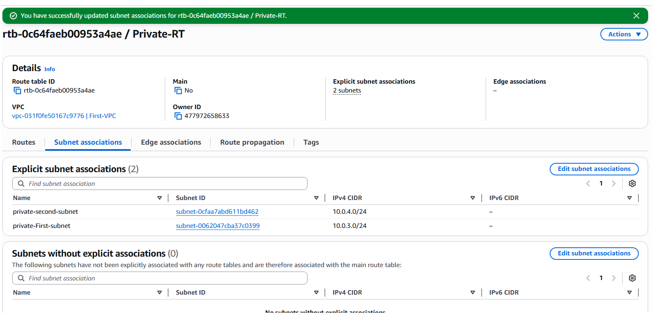
8. Install PHP on Public EC2
- ssh -i key.pem ec2-user@public-ip
- sudo yum update -y
- sudo yum install httpd php -y
- sudo systemctl start httpd
- sudo systemctl enable httpd
- http:/18.60.156.40/info.php
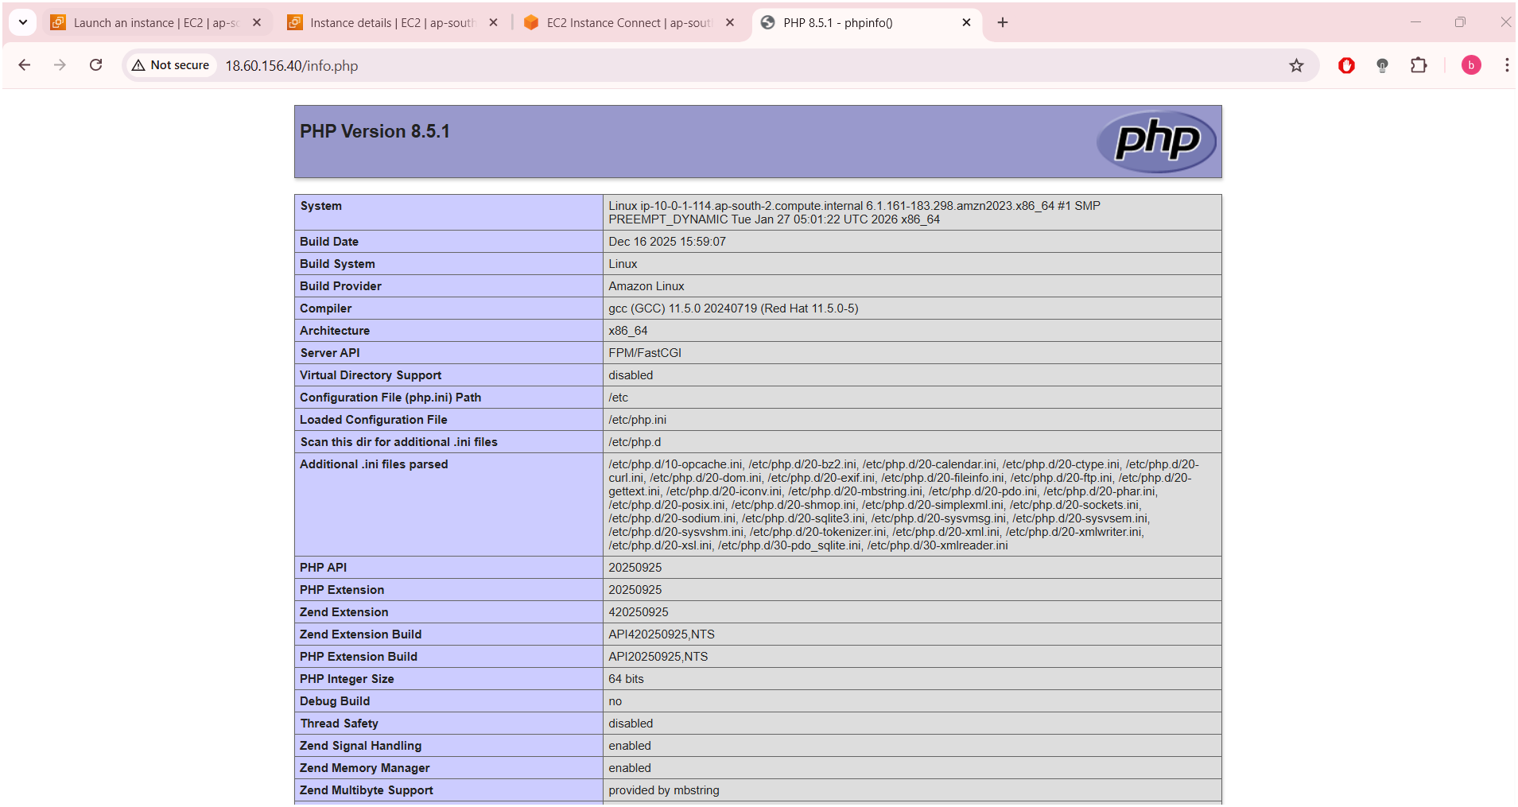

9. Create NAT Gateway
- Go to NAT Gateways
- Click Create NAT Gateway
- Subnet: Public-Subnet-1
- Allocate Elastic IP
- Create.
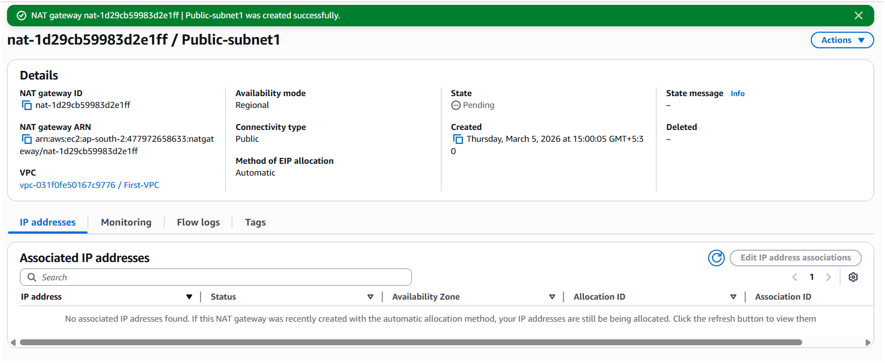
10. Update Private Route Table
- Edit Private-RT
- Add route:
- Destination | - Target
- 0.0.0.0/0 | - NAT Gateway

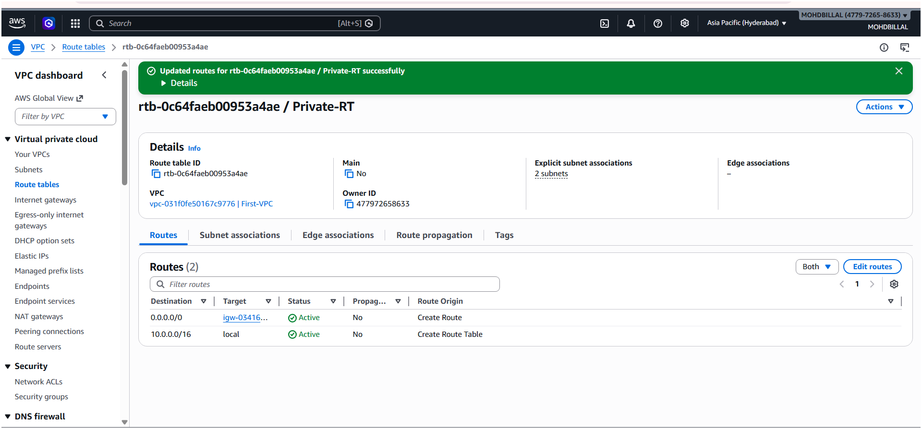

11. Launch Private EC2
- Launch instance:
- Name: Private-EC2
- Type: t2.micro
- VPC: My-VPC
- Subnet: Private-Subnet-1
- Auto assign public IP: Disabled
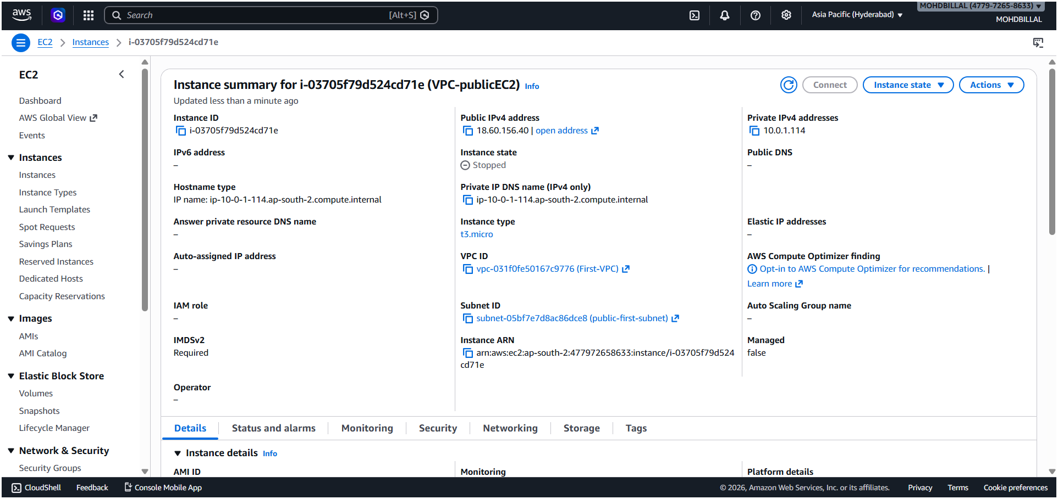

12. Install Apache Tomcat on Private EC2
- sudo yum install java-1.8.0-openjdk –y
- wget https://archive.apache.org/dist/tomcat/tomcat-9/v9.0.85/bin/apache-tomcat-9.0.85.tar.gz
- tar -xvzf apache-tomcat-9.0.85.tar.gz
- cd apache-tomcat-9.0.85/bin
- ./startup.sh
- ps -ef | grep tomcat
- http://PRIVATE-IP:8080
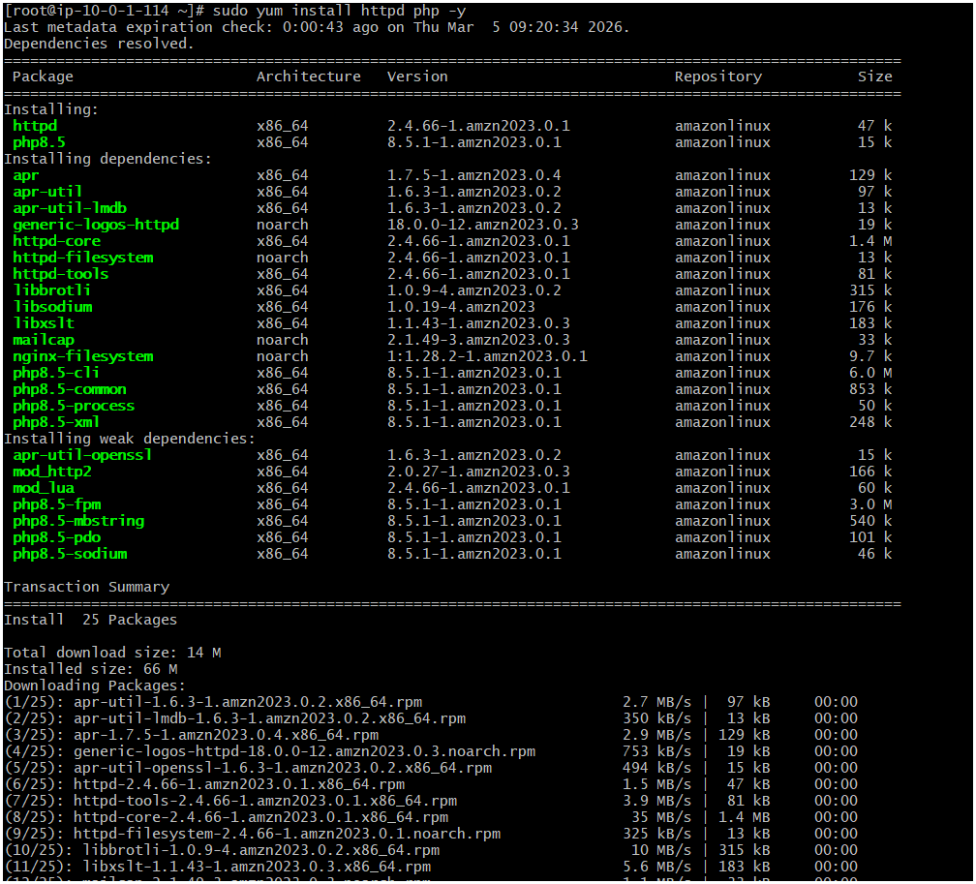

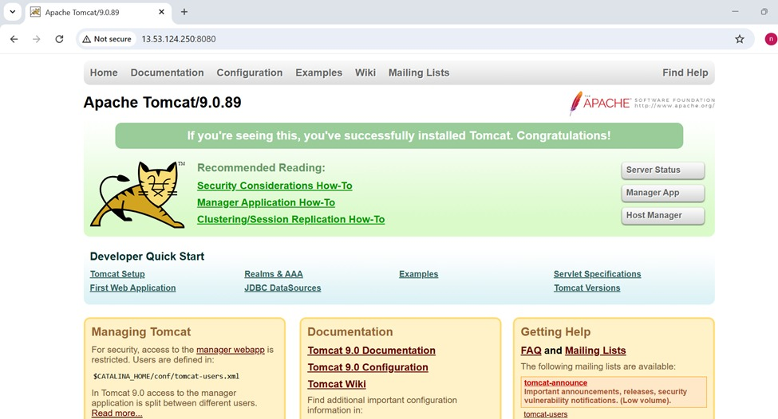

13. Deploy Sample Application
- cd apache-tomcat-9.0.85/webapps
- sample.war
- http://private-ip:8080/sample
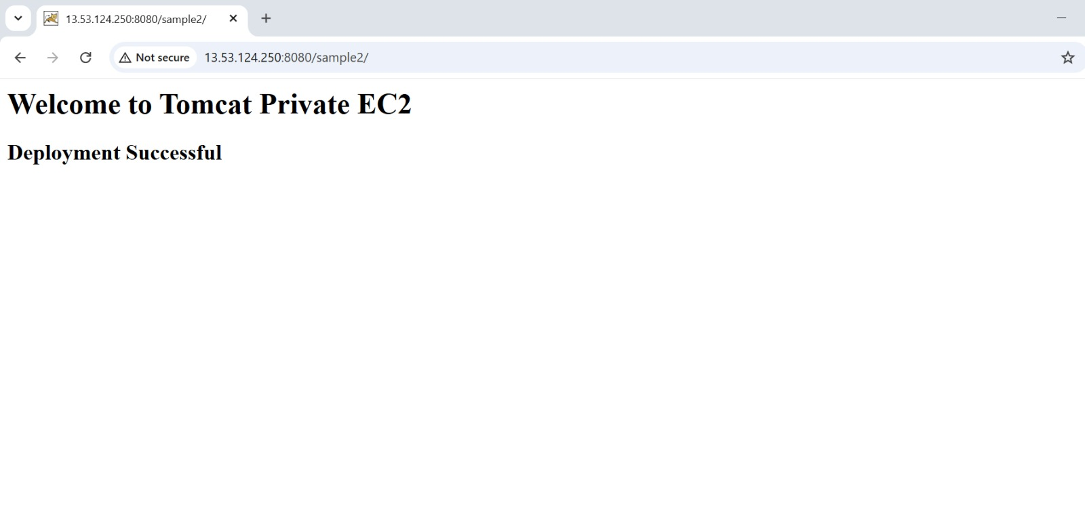

14. Configure VPC Flow Logs
- Go to VPC → Flow Logs
- Create Flow Log:
- Filter: All
- Resource: VPC
- Destination: CloudWatch Logs
- or
- Destination: S3
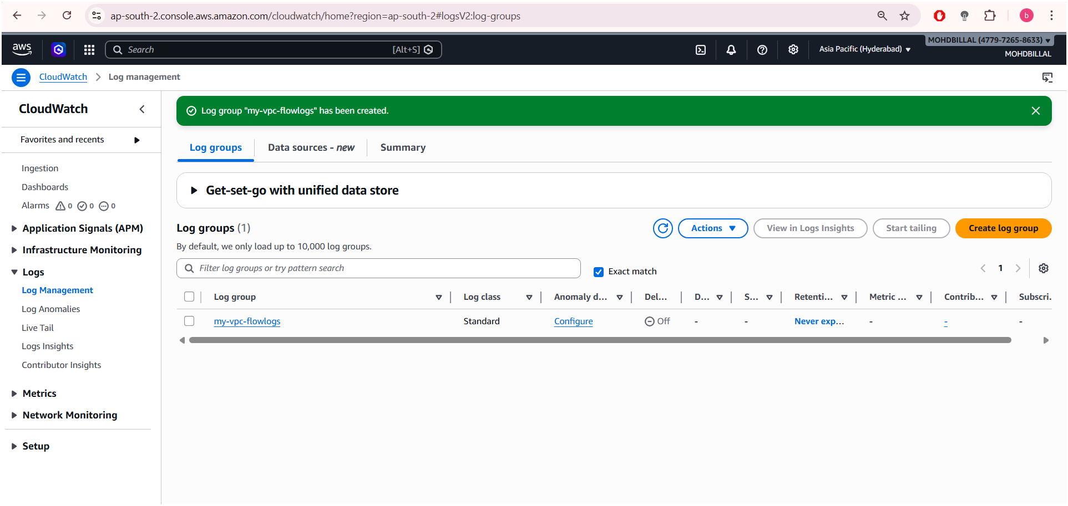

15. Store Logs in S3
- Select destination:
- Amazon S3
- Create bucket:
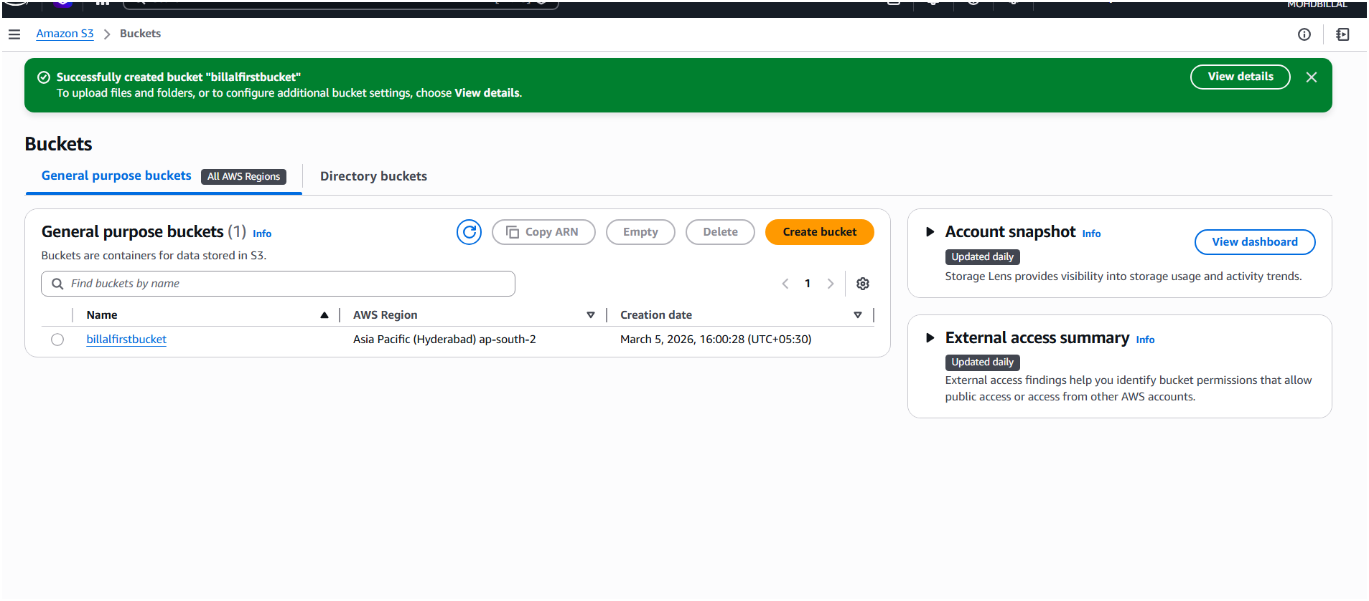

16. View Logs in CloudWatch
- Open Amazon CloudWatch
- Log Groups → VPC Flow Logs
